Digital Image Processing Exercise Report

Instructor: MITSUGAMI IKUHISA

Student ID: 81322400098

Student Name: GARCIA AARON CALVIN

Date: 2024 05 10

Explanation

Average:

Create mask of size m x m, where the size of m is user-defined and must be an odd number. The mask is overlain onto the image for each pixel in the image. All gray intensity values in the m x m square are added together and divided by m to generate an average. The center pixel value of the mask is then input into a new 2D array at the same location as the original image, for all pixels. The output is meant to smooth the pictures. However, the end result is the picture becomes more and more blurry, as m increases in size

Median:

Create mask of size m x m, where the size of m is user-defined and must be an odd number. The mask is overlain onto the image for each pixel in the image. All gray intensity values loaded into a regular 1D array of size m. The array is sorted, and the middle most value (at location of lower(m/2)) is taken, which is the median. That value is then input into a new 2D array at the same location as the original image, for all pixels. The output is meant to get rid of the salt and peppering effect of the image and turn it into a more clear picture. However, the end result is the picture becomes more and more blob-like, especially as the m increases in size.

Sharpening:

Create mask of size m x m, where the size of m must be 3. Similar to the last two filters, we overlay the mask on the image. The algorithm is then implemented as follows: take the Laplacian matrix as an an array and multiply the mask onto the image. Add the values together, and set center pixel equal to the to output of the algorithm as its intensity value. Then, scale the image by doing the following steps: Take the minimum, subtract it to all values in the Laplacian image to generate a new image (img_min) in preparation for the next step. Take the img_min and divide it my a scalar: max intensity of min_img, and finally multiply that by 255 to get the scaled image. Subtract the original by the scale Laplacian to get the final image, and lastly, normalize both the original and the final to properly display to the screen.

**Results For Median and Average:**

Original

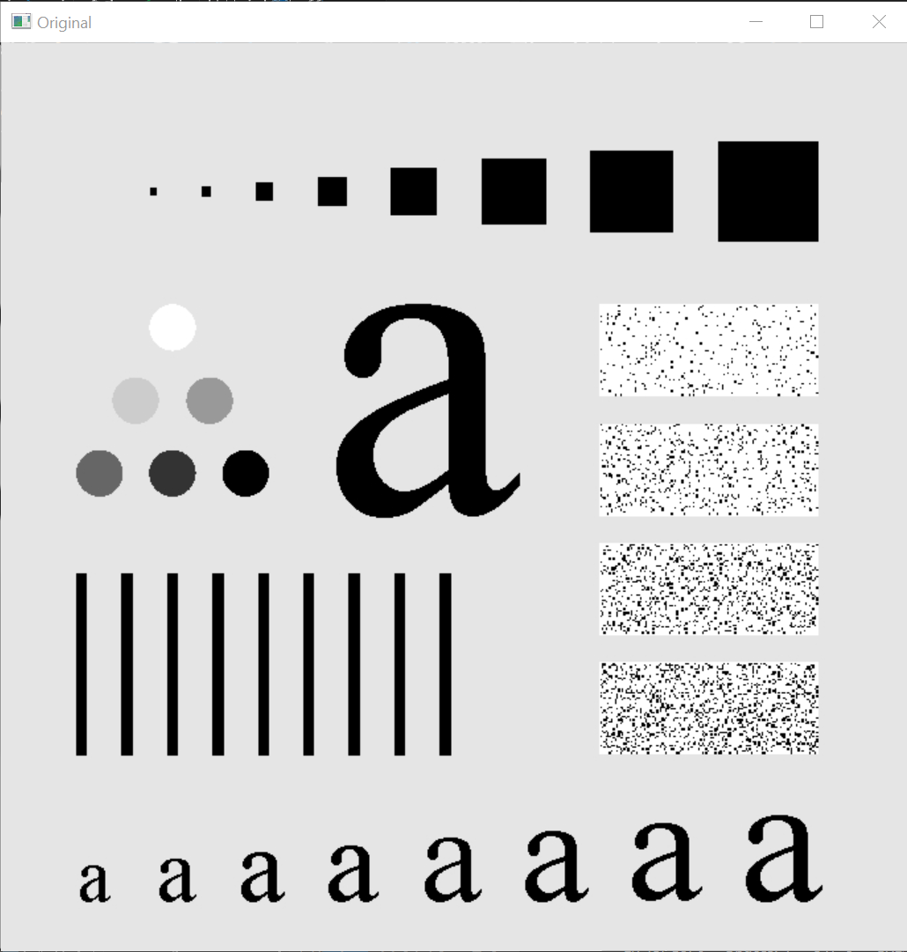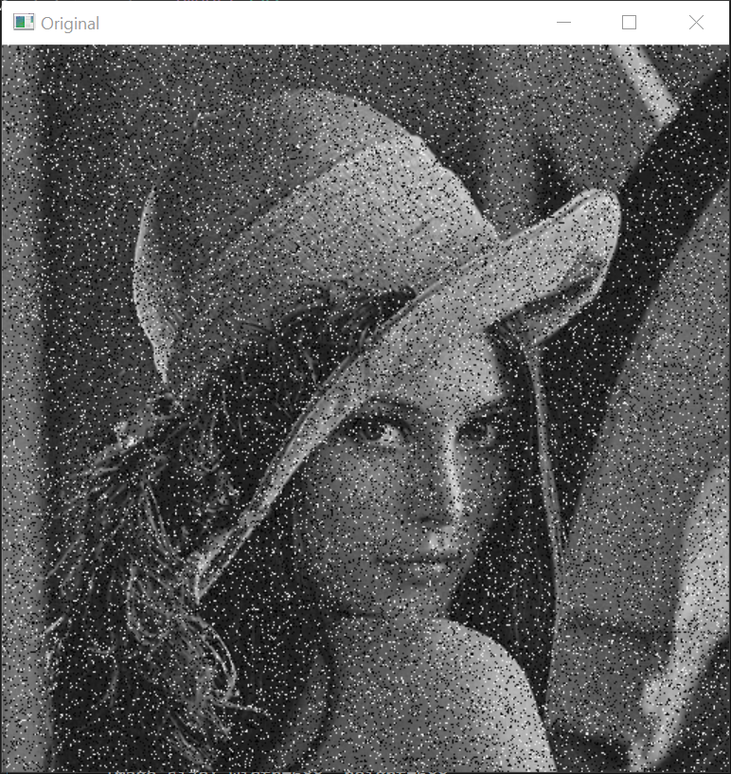m = 3

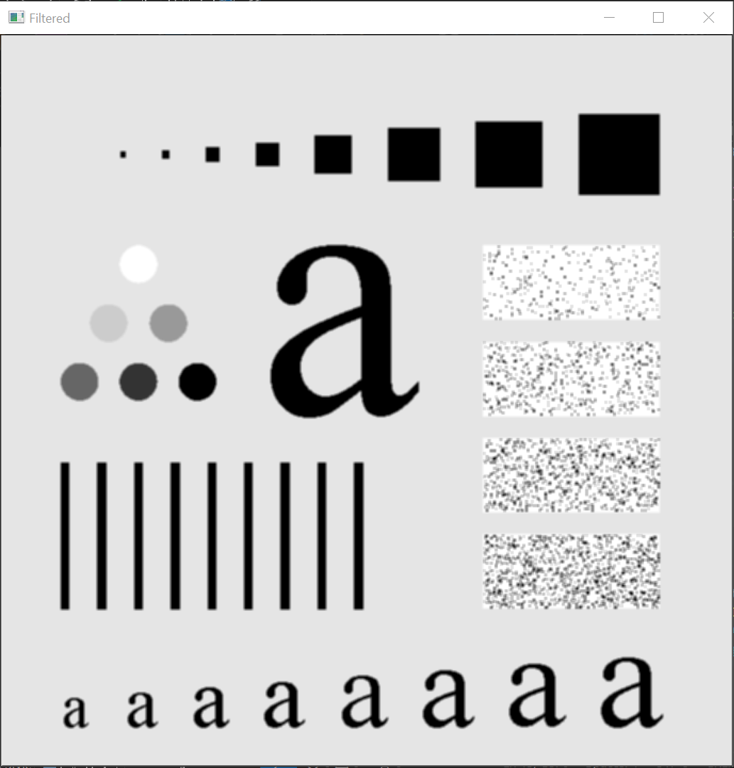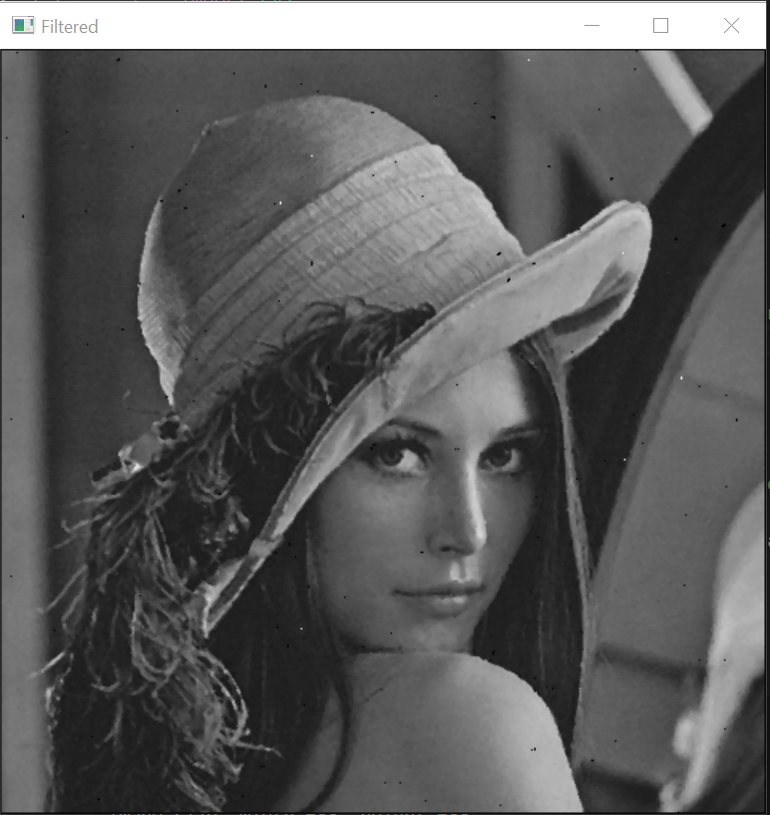

m = 5

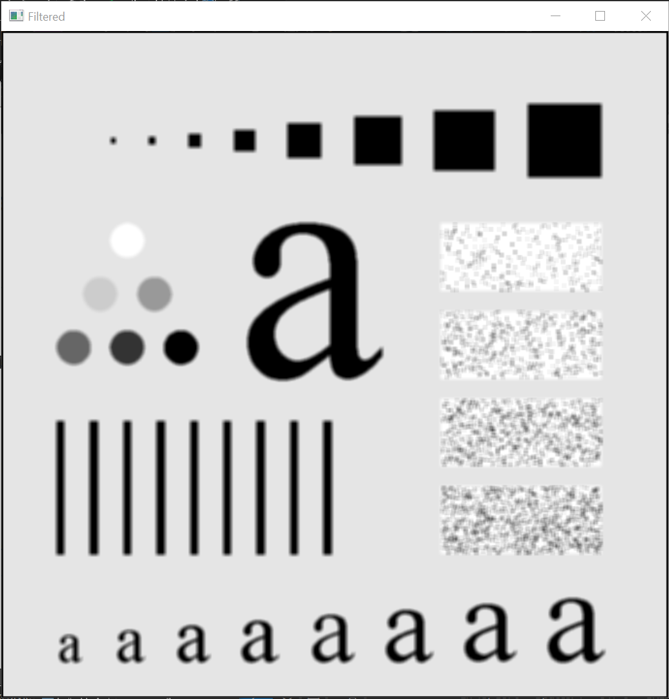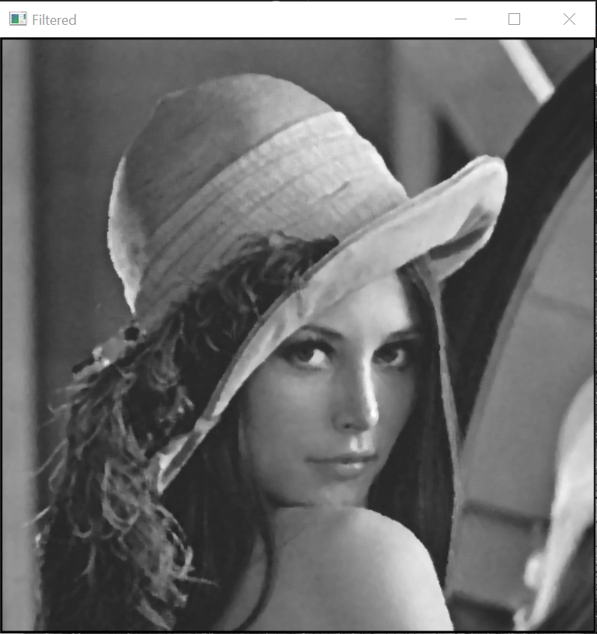m = 7

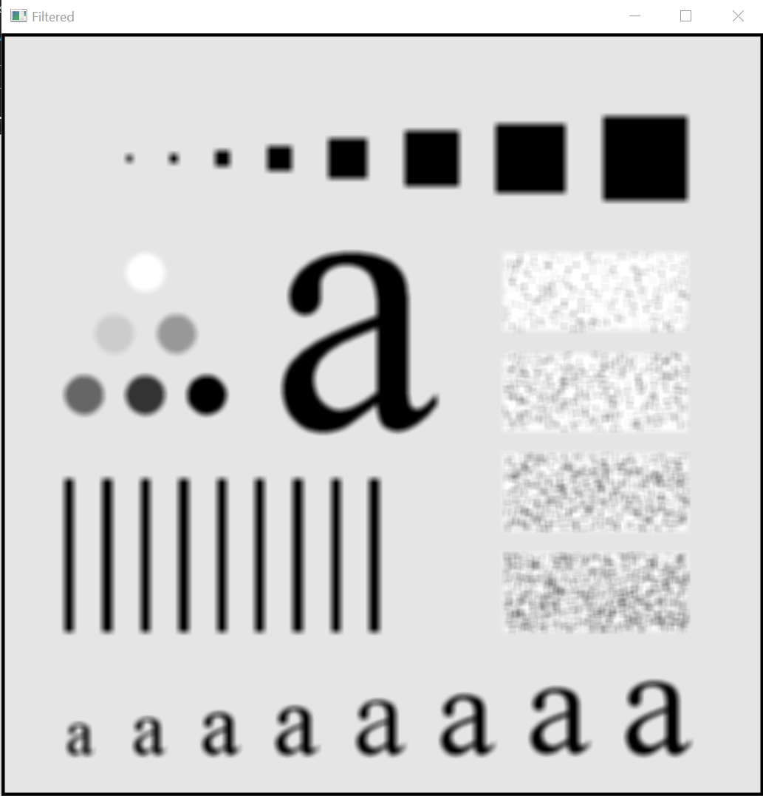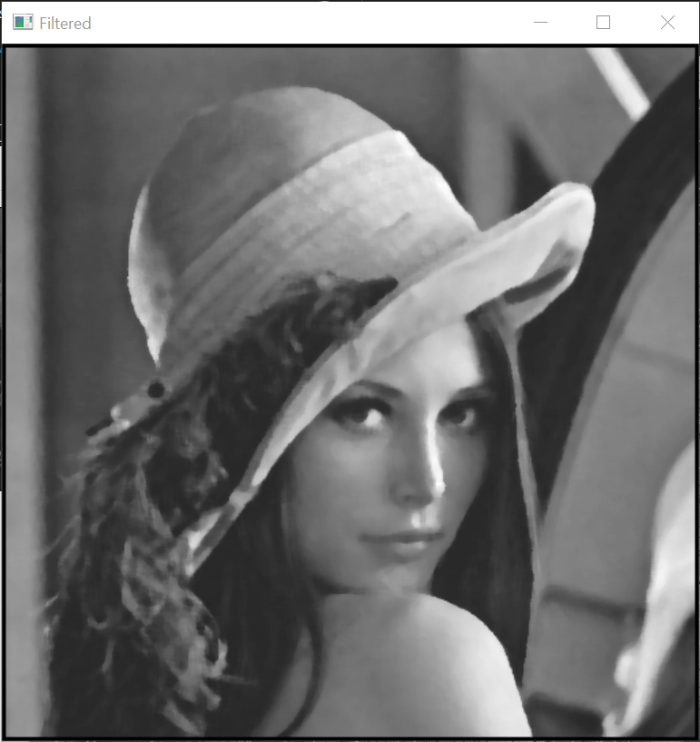

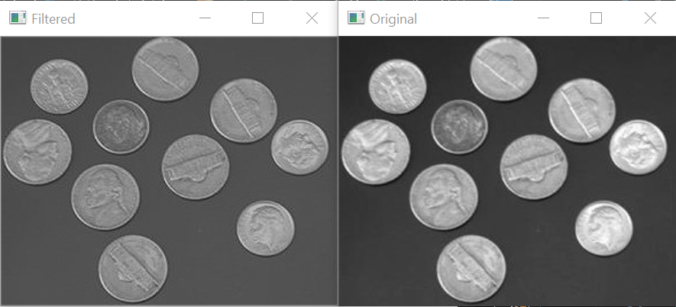**Results for Sharpening (m = 3 only)**